you are invited!
Key Topics:
- Supplies and Services
- Regulatory Update
- ELD News
- Accident Investigation & Prevention
  - Management
  - Do’s and Don’t
  - Drug & Alcohol
  - Police & Media
  - Scene Preservation

Registration Check-In: 8:30AM
Seminar Begins: 9:00AM
Lunch: Noon
Seminar Ending at 4PM

Free Lunch Provided
Locations:
April 10 – Columbus, IN
May 23 – Dayton, OH
June 14 – Fort Wayne, IN
August 29 – Canton, OH
October 17 – Perrysburg, OH 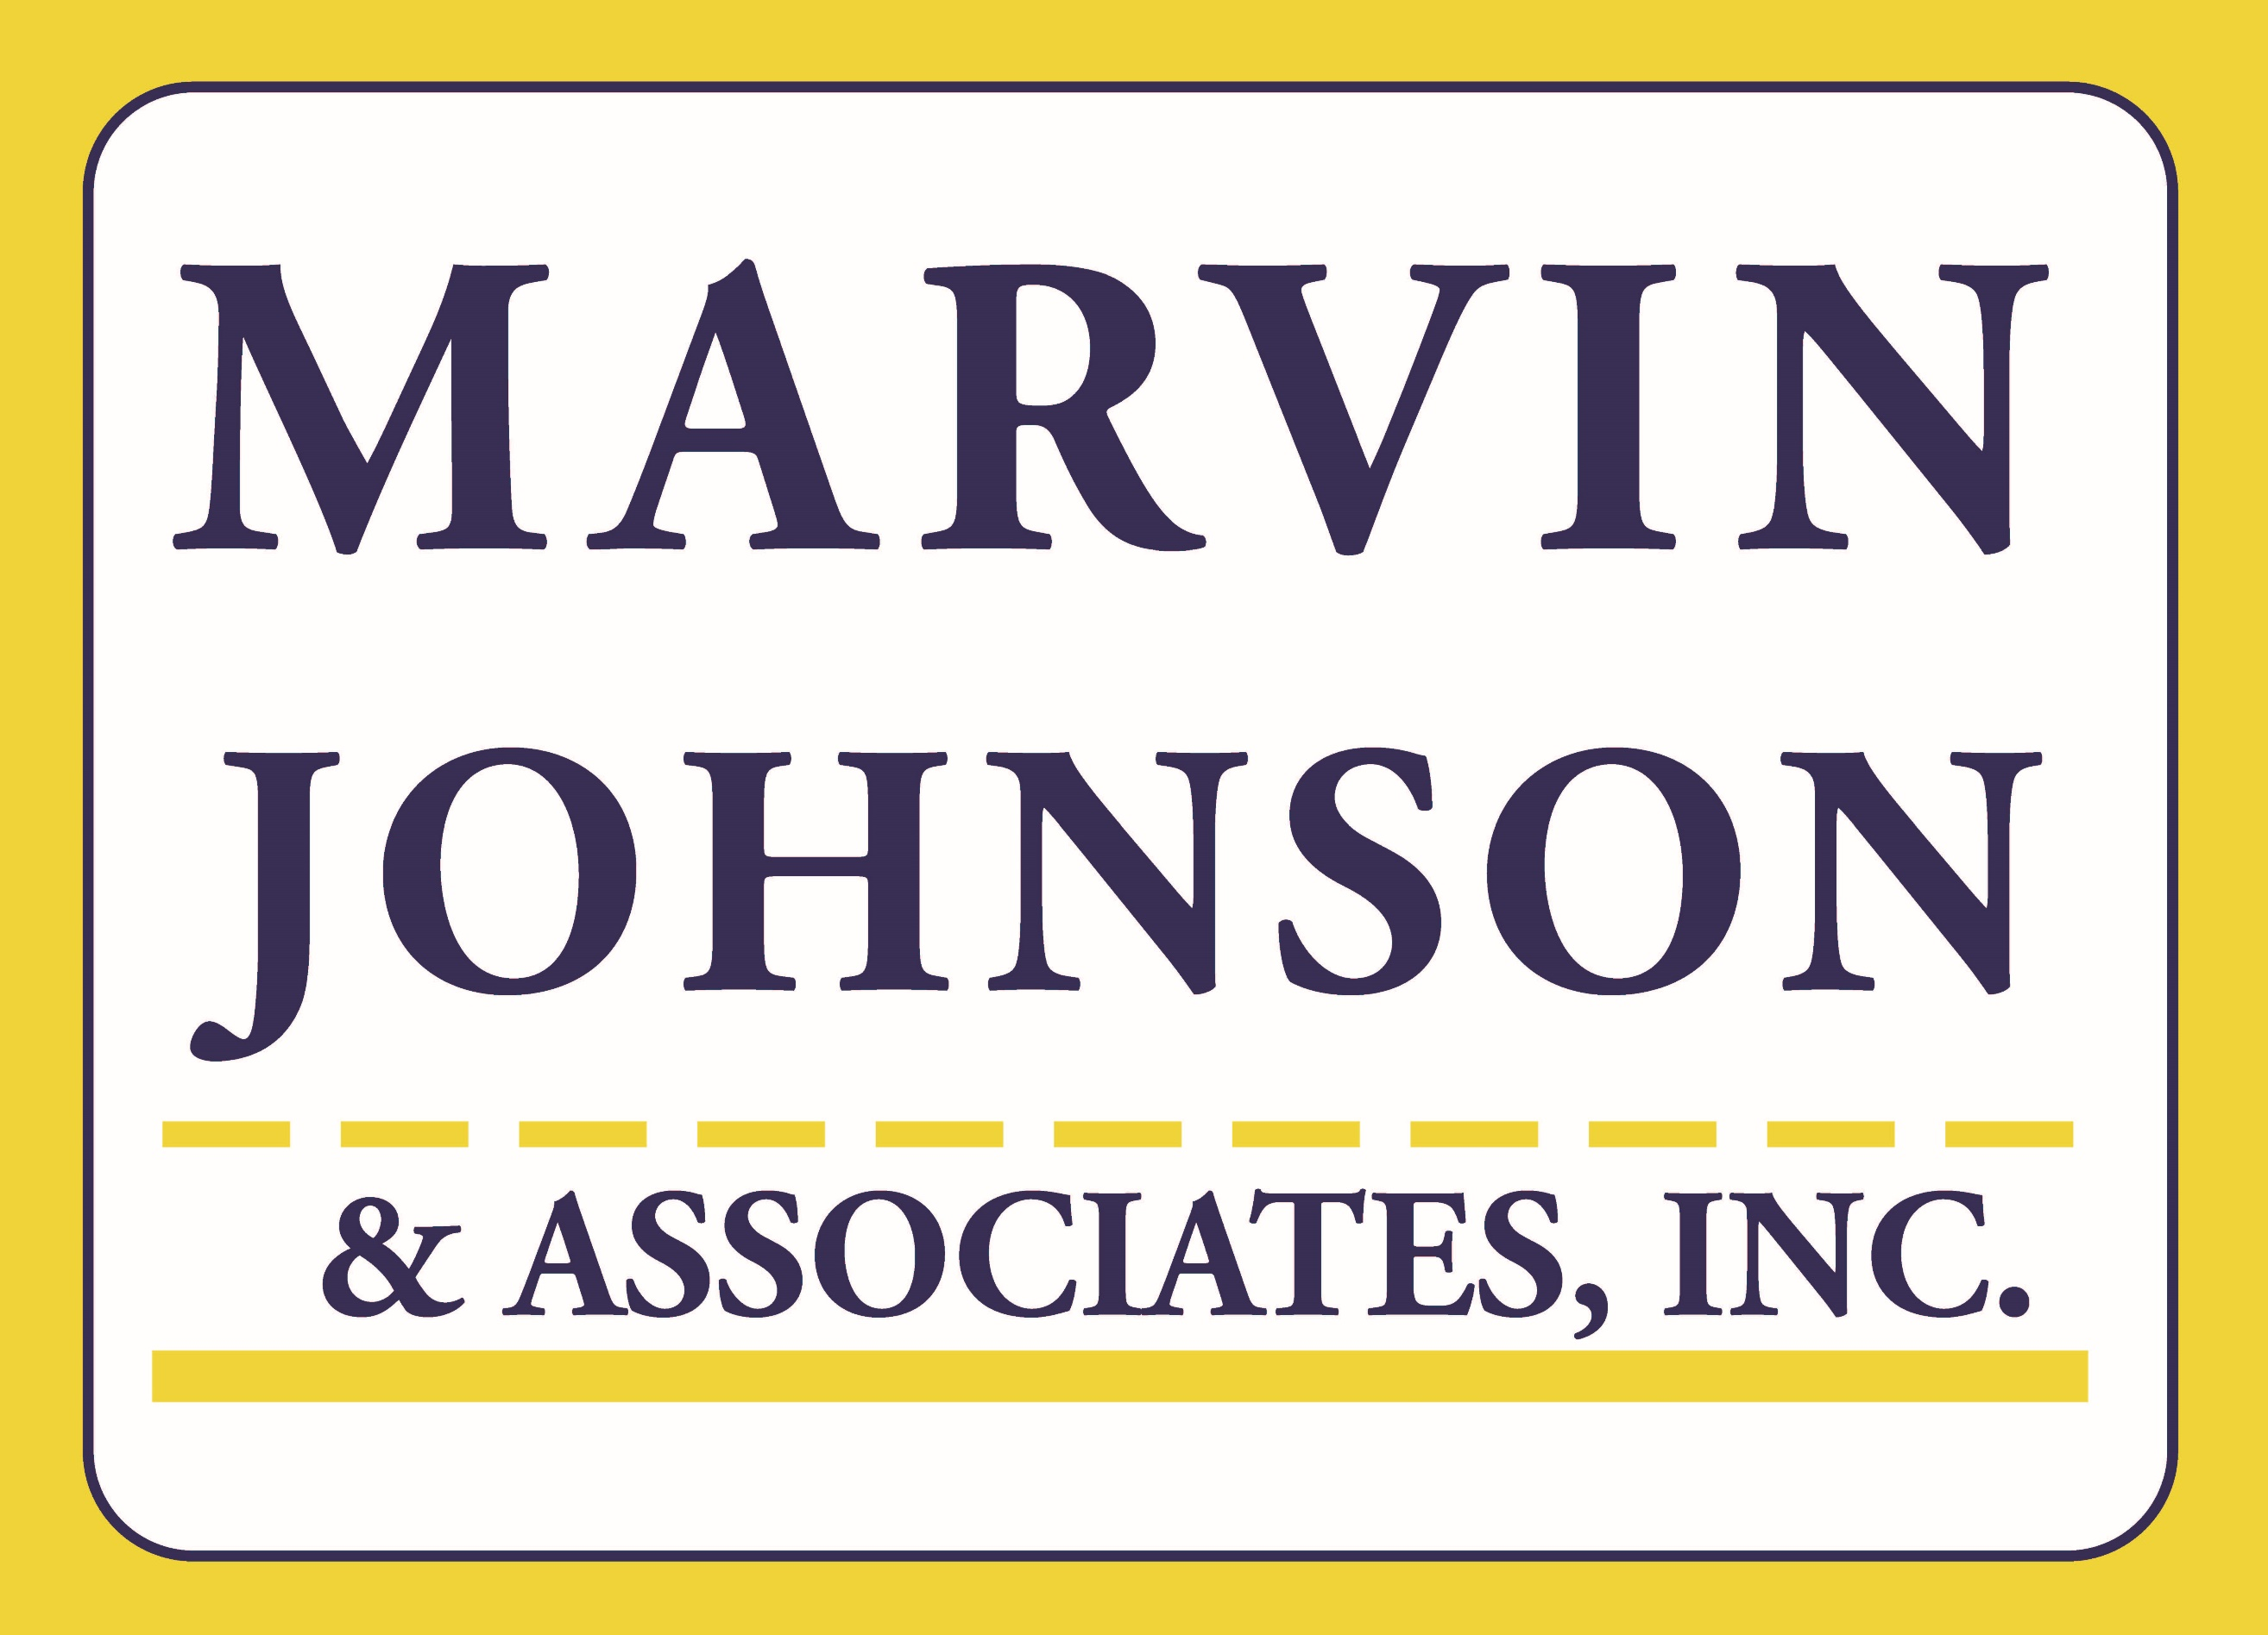

2018 Yellow Van Tour
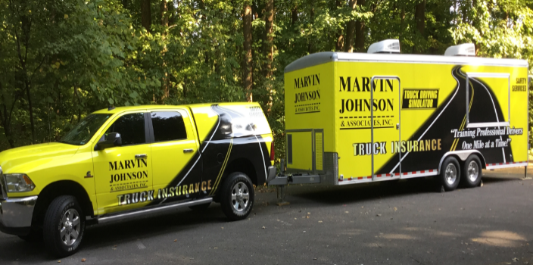
I would like to take this opportunity to invite you to attend one of our free Safety Seminars (otherwise known as The Yellow Van Tour) this year.

Title: Accident Investigation & Prevention

As usual we will spend time talking about all the products and service items we provide our clients. After that we will jump into new regulations that will impact us for 2018 along with news updates on the ELD front.

Then the meat of the day will be spent discussing Accident Investigation. This will give you an overview from start to finish of how to handle the scene of an accident. The day will move fast and we will cover topics that will save you $$$, time, and above all keep you compliant.

Please join us and some of your industry peers for a day of learning and hopefully at least a little fun. Lunch will be provided as well.

These seminars are not just for safety directors, so feel free to register other people from your office to attend. To register please complete the form below and send back either by fax to 812-372-2687 or you can scan and email to shaunaj@mjai.com. If you are registering more than one person, please complete a separate form with their contact information. This will allow us to send reminder emails as the seminar date approaches.

I hope to see you soon.

Sincerely,
Jerry Ogle, CDS
Manager, Safety & Loss Prevention

First Name:
Last Name:
Company Name:
Phone #:
Email Address:
Seminar Location:

